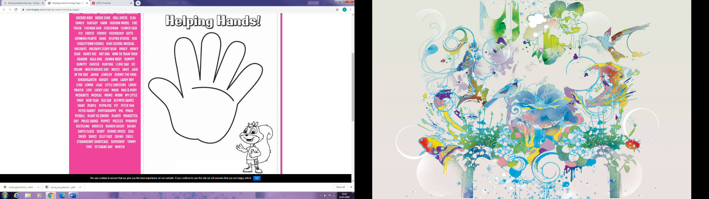

In each finger space write down a way that you could:

“Share with God’s people who are in need.”

or

“Practice hospitality.”