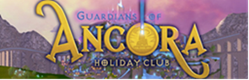
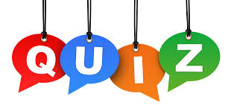
Colour in the box to show the correct answer.

- How many boats did Jesus see at the water’s edge?
12 | 2 | 6 | 100
- Who did one of the boats belong to?
Simon | Moses | Ruth | Abraham
- What had the centurion built?
An ark | A castle | A synagogue | A raft
- What did Jesus say the Centurion had?
Great strength | Great hair | Great appetite | Great faith
- Which part of Jesus did the woman in the crowd touch?
His foot | His hair | His cloak | His belt
- How old was Jairus’ daughter?
5 | 12 | 21 | 2
- What was the man who was taken, by his friends, to see Jesus unable to do?
walk | see | hear | read
- What did Jesus say to the man?
“Get up and dance.” | “Get up and run.” | “Get a move on.” | “Get up, take your mat and go home.”
- Who did Jesus ask about buying bread for the crowd of people?
Jonah | Philip | Stephen | Elijah
- How many baskets were filled with left-overs after the crowd had finished eating?
5 | 2 | 12 | 20

