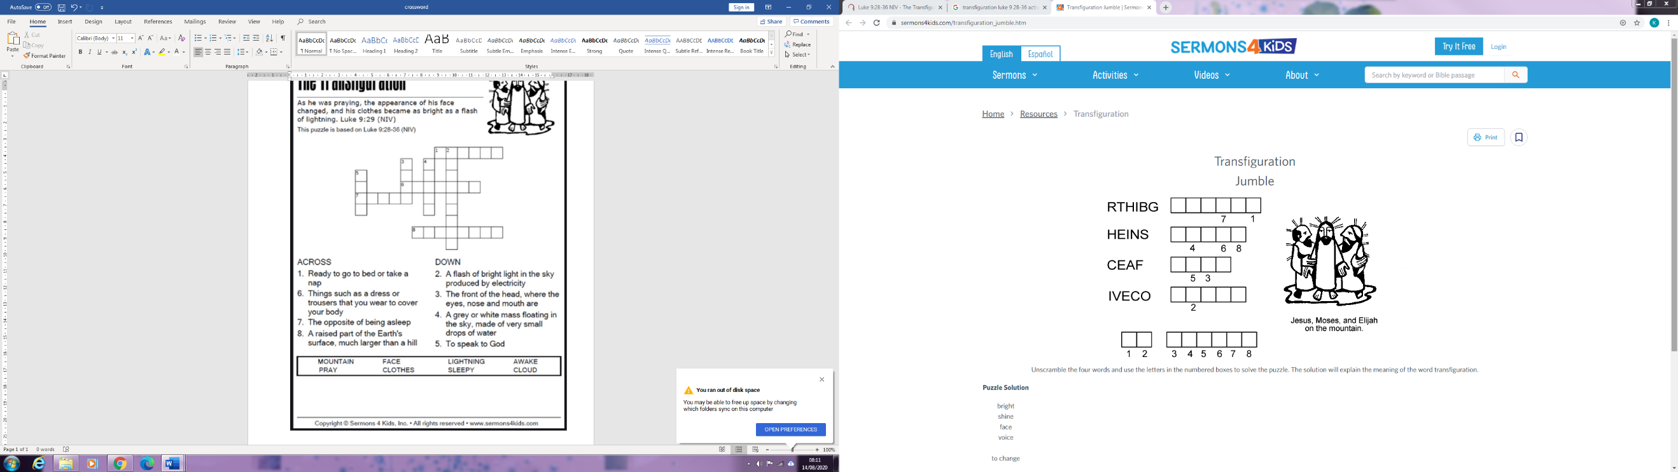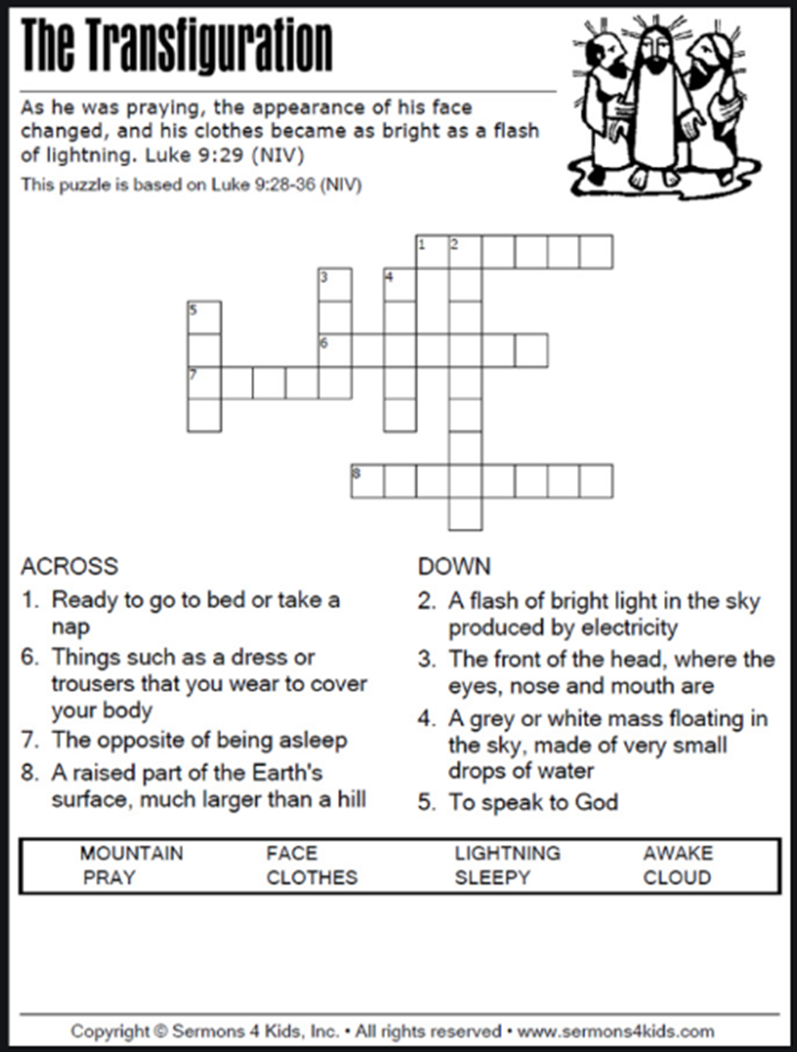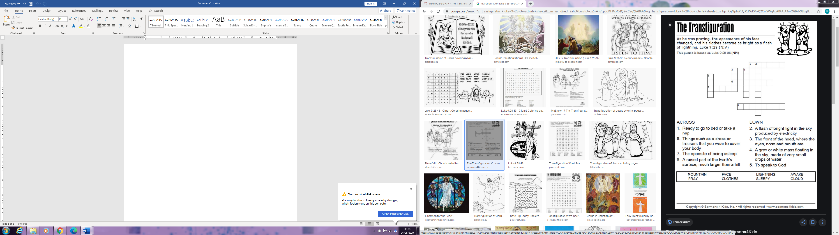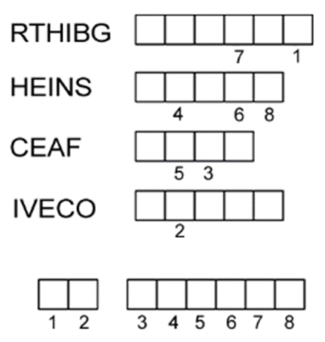

Unscramble the four words. Use the letters in the numbered boxes to solve the puzzle. The solution will explain the meaning of the word transfiguration.