**Sunday 9th August**

Find the passage in the Bible. Cut out the picture of the ‘story treasure’ found that matches the story. Stick the picture in the box above the correct Bible passage.

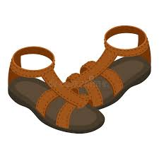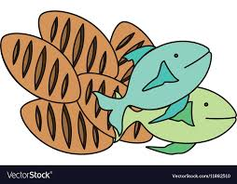

John ch 6 vs 1-15 & vs 25-35

Luke ch 5 vs 17-26

Luke ch 8 vs 40-55

Luke ch 7 vs 1-10

Luke ch 5 vs 1-11